CVR COLLEGE OF ENGINEERING

(An UGC Autonomous Institution, Affiliated to JNTUH)

**Department of Computer Science and Information Technology**

**EMERGING WEB TECHNOLOGIES**

**ASSIGNMENT-1**

1. Design a responsive web page using CSS3 media queries and view port consisting of 5 breakpoints representing different screen sizes:

0px – 576px

577px – 768px

769px – 992px

993px – 1200px

1201px – 1400px

At each breakpoint apply different background colors to the webpage

1. Design the following responsive web page using CSS3 grid layout

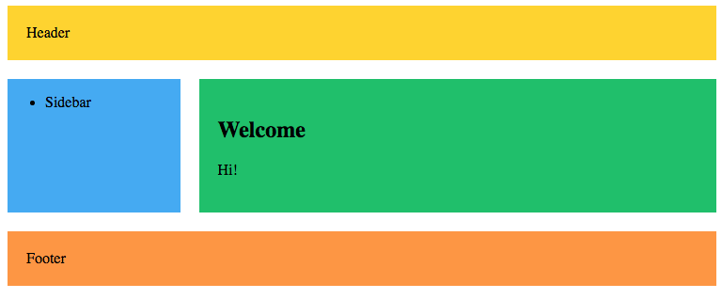

1. Validate the following XML file using External DTD and XML Schema

<?xml version="1.0" encoding="UTF-8"?>

<shiporder>

<orderperson>John Smith</orderperson>

<shipto>

<name>Ola Nordmann</name>

<address>Langgt 23</address>

<city>4000 Stavanger</city>

<country>Norway</country>

</shipto>

<item>

<title>Empire Burlesque</title>

<note>Special Edition</note>

<quantity>1</quantity>

<price>10.90</price>

</item>

<item>

<title>Hide your heart</title>

<quantity>1</quantity>

<price>9.90</price>

</item>

</shiporder>

1. Design a HTML and JavaScript to perform the following:

i) Accept two numbers from user

ii) Find the GCD and LCM of the accepted numbers using function

iii) Display the results with appropriate messages.

1. Create a Web server using node.js *http* module that listens to client requests on port number *8084* and sends an HTML page with a message *“Hello CSIT”* as a response.